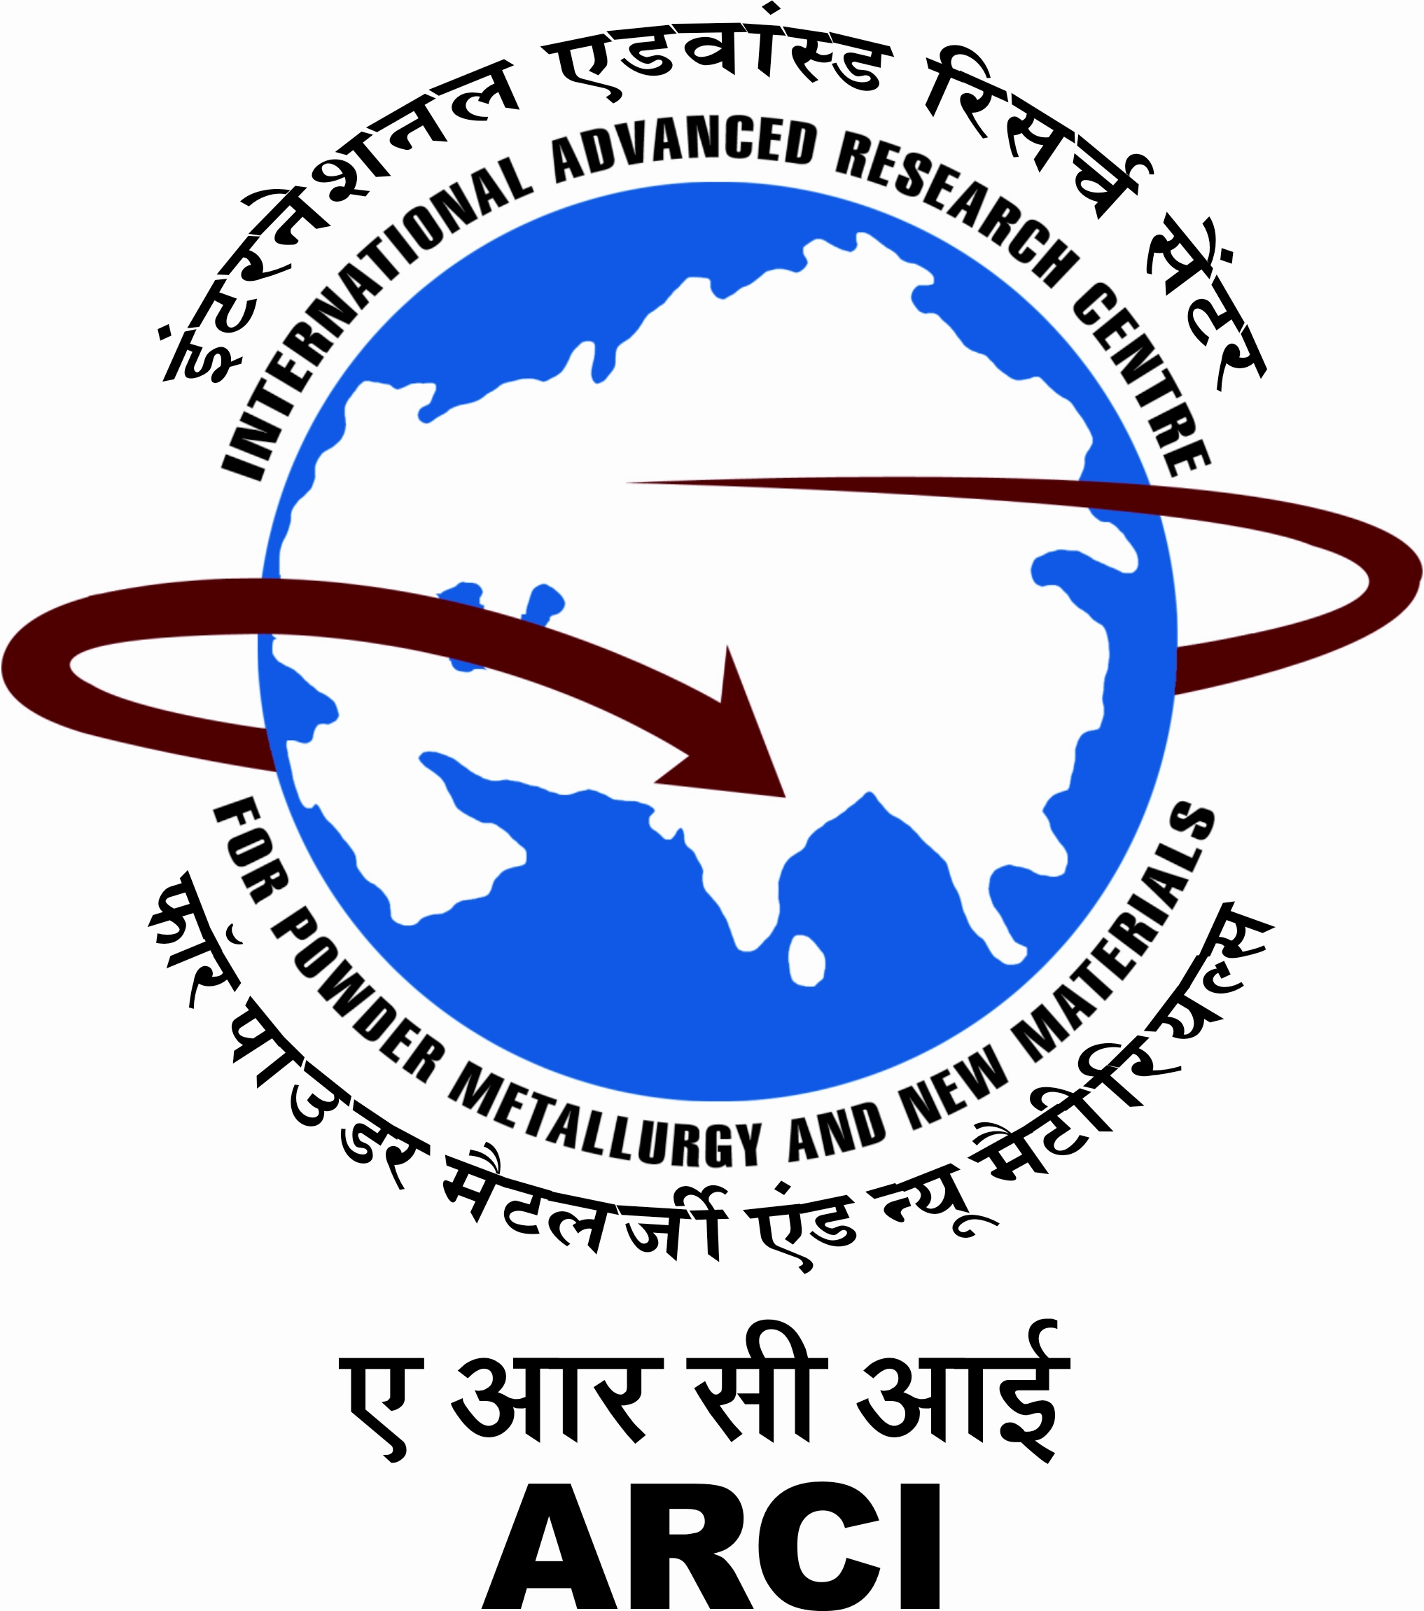
INTERNATIONAL ADVANCED RESEARCH CENTRE FOR POWDER
METALLURGY AND NEW MATERIALS (ARCI), HYDERABAD

(for Office Use only)
Date of Receipt : |  | Application No :
APPLICATION FORM
Advertisement No | : | ARCI/HRD/SP/CONTRACT/RECT/1/2015  Paste/Affix scanned recent passport size photograph. Affix scanned sign

Time-bound Project | : | Thematic Unit of Excellence on Nanomaterial-based Technologies for Automotive Applications -STNA

Post Code | : | S 001 |  | Post Name | : | Project Scientist (Middle Level)

Nature of Post | : | CONTRACT BASIS

Name of the Applicant | :

Father’s/Husband Name | :

Date of Birth | :
 |  | Day |  |  |  | Month |  |  |  |  | Year

Age as on closing date (21.07.2015) | : | Years |  |  | Months |  |  | Days

Community | :
 |  | SC | ST |  | OBC |  | Others
In case of Persons with Disabilities, please specify nature of disability (OH/HH/VH) | :

Sex | : | Male |  | Female

Religion | :

Nationality | :

Marital Status | : | Married |  | Unmarried

Essential Qualification | : |  | Subject

Year of Passing | :

Name of the University/Board | :

Class | : |  |  | Aggregate : | %

Present Address | :
 | :
City | :
State | :
Phone No | :
E-Mail | :

Permanent Address | :
City | :
State | :
Phone No | :

Educational Qualifications (Matric onwards in chorological order) :
Sl.  No | Examination Passed | Year of Passing | Name of School/College | Name of Board/University | Class & % of Marks | Main Subject (s)

Please give an abstract of your work carried out as M.Sc./B.Tech./M.Tech.project or M.S. thesis. Attach the abstract also.

Date of Registration for Ph.D.*

Duration spent on Ph.D. (from dd/mm/yy to dd/mm/yy)*

Date of award of Ph.D.*

If you have been registered/awarded Ph.D. degree, please specify the title of Ph.D. thesis and attach the abstract also.*
If you are presently working, nature of employment,
type of appointment and present gross salary/ emoluments.*

Professional Experience/Details of Employment (use separate sheet if required)*

Name & Address of Employer | Designation &  Gross Pay/ Emoluments | Period of Service  (dd/mm/yy) |  | No. of Yrs. of Expr. Acquired | Nature of Duties
Name & Address of Employer | Designation &  Gross Pay/ Emoluments | From | To | No. of Yrs. of Expr. Acquired | Nature of Duties

Present Job Description  in brief * | :

* In applicable cases only please give details, otherwise say not applicable

Please give a brief write up of your research experience consistent with the theme of the sponsored project *  (Please use additional sheet, if required) | :

Please justify, how your  research experience matches with the post you are applying for :*  (Please use additional sheet, if required) | :
* In applicable cases only please give details, otherwise say not applicable

Papers/Reports Published (Use additional sheet, if required) | :

Patents awarded, if any | :

Please briefly indicate your familiarity with Computers and its application software | :

Names of the referees and their current address with phone/fax/email  (one of the reference should be preferably from the current/most recent employer or immediate superior) |  | 1) | 2)
 |  | 3)

Any other Information | :

Have you ever applied for any post in ARCI earlier? If yes, please give details. | : | Yes / No |  | Whether related to any ARCI employee. If yes, ARCI employee’s name and designation | Yes / No

DECLARATION

I declare that I fulfill the eligibility conditions as per the advertisement and that all the statements made in this application are true, complete and correct to the best of my knowledge and belief. I understand that in the event of any information being found false or incorrect at any stage or not satisfying the eligibility conditions according to the requirements mentioned in the advertisement, my candidature/contract appointment is liable to be cancelled/ terminated. I also undertake to state that the contract appointment is purely temporary and co-terminus with the time-bound sponsored project “Thematic Unit of Excellence on Nanomaterial-based Technologies for Automotive Applications”(STNA), or earlier, purely based on my performance. I shall not have any right to claim for regular appointment or permanent absorption in ARCI/DST. I also declare that, I have read and understood all of the general terms and conditions listed in the advertisement and that I shall abide by them.

Place: Signature of the Candidate with date

